Name: ________________________________________ Due Date: _________________________

Visca AP Calculus AB – Final Review Weekly #2 (CW) ***DUE: 2/12/18***

2016 section II, #2 – ***YES graphing calculator required***

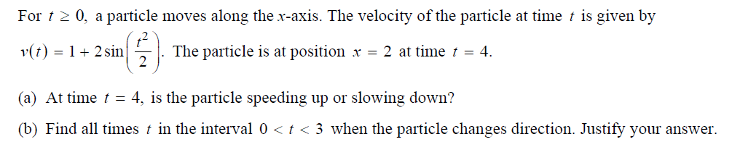

2016 section II, #6 – ***NO graphing calculator allowed!!!***

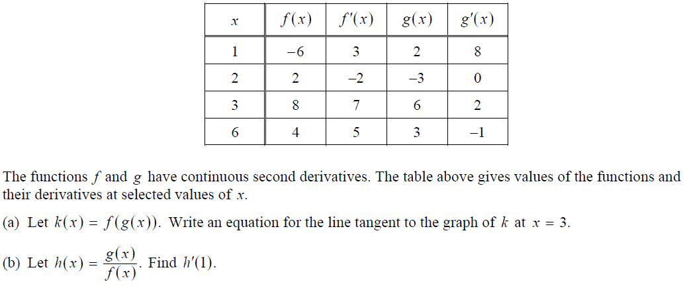

1998 section I, #6 – ***NO graphing calculator allowed!!!***

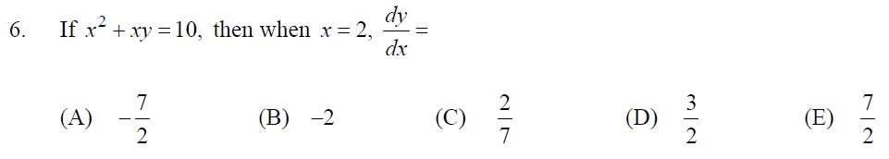

1998 section I, #12 – ***NO graphing calculator allowed!!!***

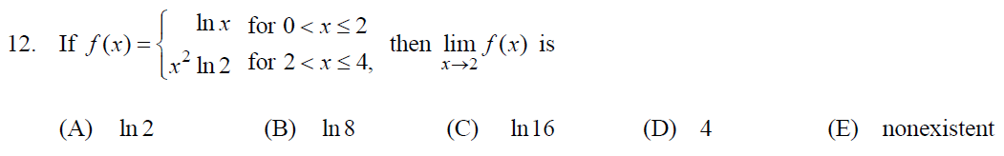

1998 section I, #16 – ***NO graphing calculator allowed!!!***





1998 section I, #77 – ***YES graphing calculator required***

